МИНОБРНАУКИ РОССИИ

Федеральное государственное бюджетное образовательное

учреждение высшего образования

«Ижевский государственный технический университет имени М.Т. Калашникова»

(ФГБОУ ВО «ИжГТУ имени М.Т. Калашникова»)

Кафедра «Программное обеспечение»

Отчет

по лабораторной работе №3

по дисциплине «Архитектура электронно-вычислительных машин»

Выполнил:

студент группы Б04-191- 3 Р. А. Гумметов

Принял: А. Х. Аль Аккад

Ижевск 2020

**ЗАДАНИЕ 1.**

**Реализация SISO регистра в Logisim.**

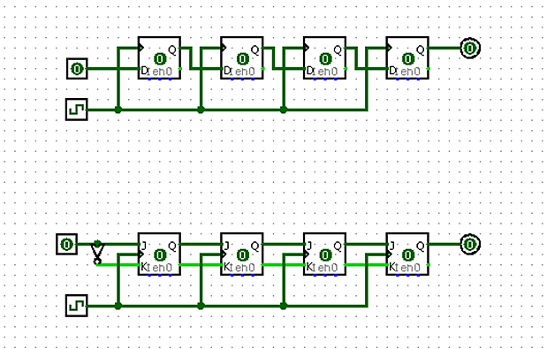

Рис. 1 – реализация регистра SISOв Logisim

**Реализация PISO регистра в Logisim.**

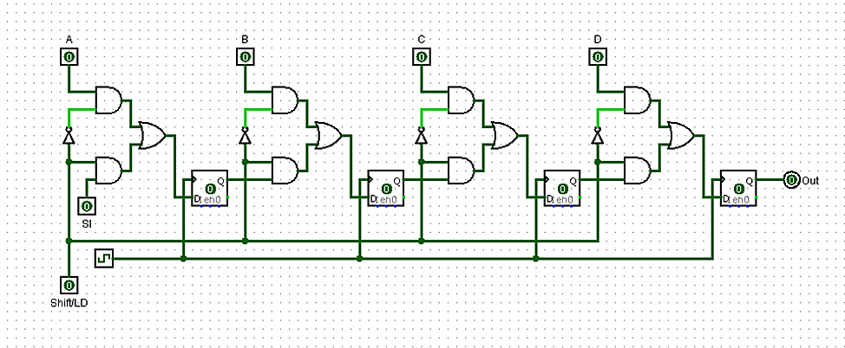

Рис. 2 – реализация регистра PISO в Logisim

**ЗАДАНИЕ 2.**

**Реализация SISO регистра в Quartus.**

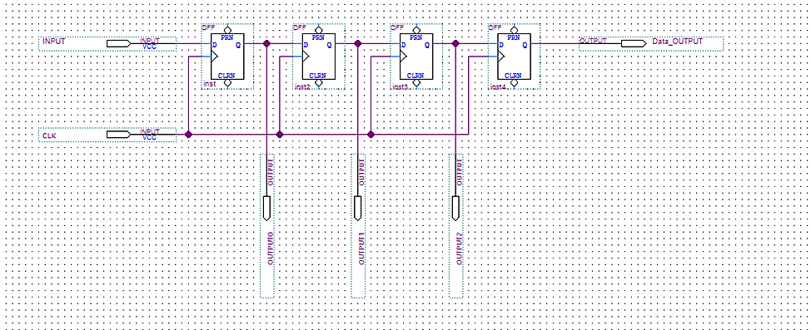

Рис. 3 – реализация регистра SISO в Quartus

**Полученный VHDL:**

LIBRARY ieee;

USE ieee.std_logic_1164.all;

LIBRARY work;

ENTITY Block1 IS

PORT

(

CLK : IN STD_LOGIC;

INPUT : IN STD_LOGIC;

Data_OUTPUT : OUT STD_LOGIC;

OUTPUT2 : OUT STD_LOGIC;

OUTPUT1 : OUT STD_LOGIC;

OUTPUT0 : OUT STD_LOGIC

);

END Block1;

ARCHITECTURE bdf_type OF Block1 IS

SIGNAL DFF_inst : STD_LOGIC;

SIGNAL DFF_inst2 : STD_LOGIC;

SIGNAL DFF_inst3 : STD_LOGIC;

BEGIN

OUTPUT2 <= DFF_inst3;

OUTPUT1 <= DFF_inst2;

OUTPUT0 <= DFF_inst;

PROCESS(CLK)

BEGIN

IF (RISING_EDGE(CLK)) THEN

DFF_inst<= INPUT;

END IF;

END PROCESS;

PROCESS(CLK)

BEGIN

IF (RISING_EDGE(CLK)) THEN

DFF_inst2 <= DFF_inst;

END IF;

END PROCESS;

PROCESS(CLK)

BEGIN

IF (RISING_EDGE(CLK)) THEN

DFF_inst3 <= DFF_inst2;

END IF;

END PROCESS;

PROCESS(CLK)

BEGIN

IF (RISING_EDGE(CLK)) THEN

Data_OUTPUT<= DFF_inst3;

END IF;

END PROCESS;

END bdf_type;

**Симуляция дизайна:**

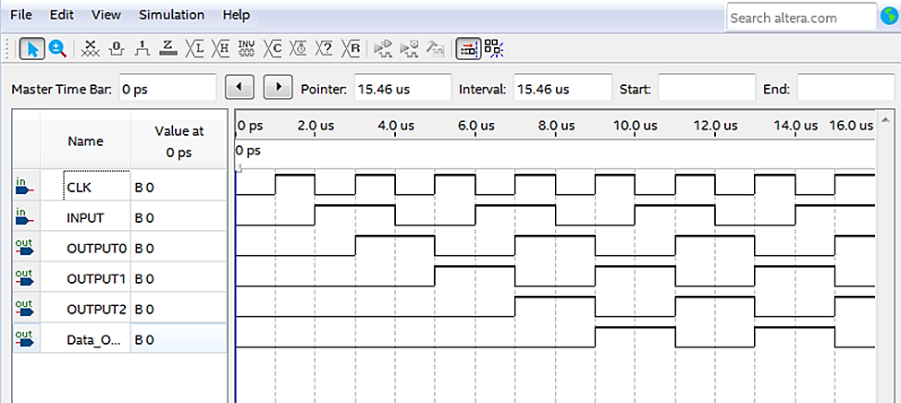

Рис. 4

**Реализация PISO регистра в Quartus.**

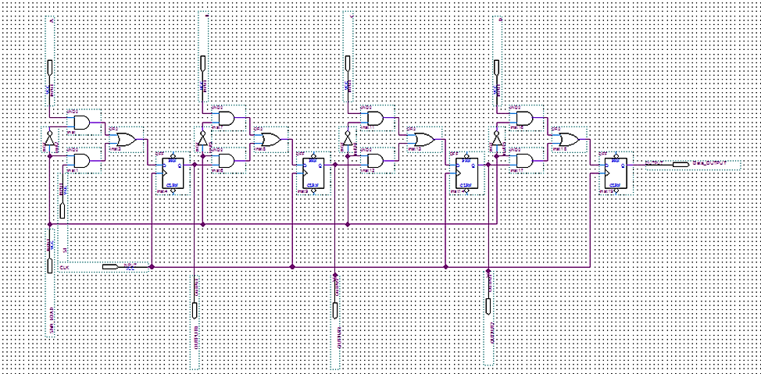

Рис. 5 – реализация регистра PISO в Quartus

**Полученный VHDL:**

LIBRARY ieee;

USE ieee.std_logic_1164.all;

LIBRARY work;

ENTITY Block1 IS

PORT

(

A : IN STD_LOGIC;

SI : IN STD_LOGIC;

B : IN STD_LOGIC;

C : IN STD_LOGIC;

D : IN STD_LOGIC;

Shift_LOAD : IN STD_LOGIC;

CLK : IN STD_LOGIC;

Data_OUTPUT : OUT STD_LOGIC;

OUTPUT0 : OUT STD_LOGIC;

OUTPUT1 : OUT STD_LOGIC;

OUTPUT2 : OUT STD_LOGIC

);

END Block1;

ARCHITECTURE bdf_type OF Block1 IS

SIGNAL SYNTHESIZED_WIRE_0 : STD_LOGIC;

SIGNAL SYNTHESIZED_WIRE_1 : STD_LOGIC;

SIGNAL DFF_inst9 : STD_LOGIC;

SIGNAL SYNTHESIZED_WIRE_2 : STD_LOGIC;

SIGNAL SYNTHESIZED_WIRE_3 : STD_LOGIC;

SIGNAL SYNTHESIZED_WIRE_4 : STD_LOGIC;

SIGNAL SYNTHESIZED_WIRE_5 : STD_LOGIC;

SIGNAL DFF_inst14 : STD_LOGIC;

SIGNAL SYNTHESIZED_WIRE_6 : STD_LOGIC;

SIGNAL SYNTHESIZED_WIRE_7 : STD_LOGIC;

SIGNAL SYNTHESIZED_WIRE_8 : STD_LOGIC;

SIGNAL SYNTHESIZED_WIRE_9 : STD_LOGIC;

SIGNAL SYNTHESIZED_WIRE_10 : STD_LOGIC;

SIGNAL SYNTHESIZED_WIRE_11 : STD_LOGIC;

SIGNAL DFF_inst4 : STD_LOGIC;

SIGNAL SYNTHESIZED_WIRE_12 : STD_LOGIC;

SIGNAL SYNTHESIZED_WIRE_13 : STD_LOGIC;

SIGNAL SYNTHESIZED_WIRE_14 : STD_LOGIC;

SIGNAL SYNTHESIZED_WIRE_15 : STD_LOGIC;

BEGIN

OUTPUT0 <= DFF_inst4;

OUTPUT1 <= DFF_inst9;

OUTPUT2 <= DFF_inst14;

SYNTHESIZED_WIRE_10 <= A AND SYNTHESIZED_WIRE_0;

SYNTHESIZED_WIRE_9 <= Shift_LOAD AND SI;

SYNTHESIZED_WIRE_1 <= NOT(Shift_LOAD);

SYNTHESIZED_WIRE_3 <= C AND SYNTHESIZED_WIRE_1;

SYNTHESIZED_WIRE_2 <= Shift_LOAD AND DFF_inst9;

SYNTHESIZED_WIRE_4 <= SYNTHESIZED_WIRE_2 OR SYNTHESIZED_WIRE_3;

PROCESS(CLK)

BEGIN

IF (RISING_EDGE(CLK)) THEN

DFF_inst14 <= SYNTHESIZED_WIRE_4;

END IF;

END PROCESS;

SYNTHESIZED_WIRE_5 <= NOT(Shift_LOAD);

SYNTHESIZED_WIRE_7 <= D AND SYNTHESIZED_WIRE_5;

SYNTHESIZED_WIRE_6 <= Shift_LOAD AND DFF_inst14;

SYNTHESIZED_WIRE_8 <= SYNTHESIZED_WIRE_6 OR SYNTHESIZED_WIRE_7;

PROCESS(CLK)

BEGIN

IF (RISING_EDGE(CLK)) THEN

Data_OUTPUT<= SYNTHESIZED_WIRE_8;

END IF;

END PROCESS;

SYNTHESIZED_WIRE_0 <= NOT(Shift_LOAD);

SYNTHESIZED_WIRE_11 <= SYNTHESIZED_WIRE_9 OR SYNTHESIZED_WIRE_10;

PROCESS(CLK)

BEGIN

IF (RISING_EDGE(CLK)) THEN

DFF_inst4 <= SYNTHESIZED_WIRE_11;

END IF;

END PROCESS;

SYNTHESIZED_WIRE_12 <= NOT(Shift_LOAD);

SYNTHESIZED_WIRE_13 <= Shift_LOAD AND DFF_inst4;

SYNTHESIZED_WIRE_14 <= B AND SYNTHESIZED_WIRE_12;

SYNTHESIZED_WIRE_15 <= SYNTHESIZED_WIRE_13 OR SYNTHESIZED_WIRE_14;

PROCESS(CLK)

BEGIN

IF (RISING_EDGE(CLK)) THEN

DFF_inst9 <= SYNTHESIZED_WIRE_15;

END IF;

END PROCESS;

END bdf_type;

**Симуляция дизайна:**

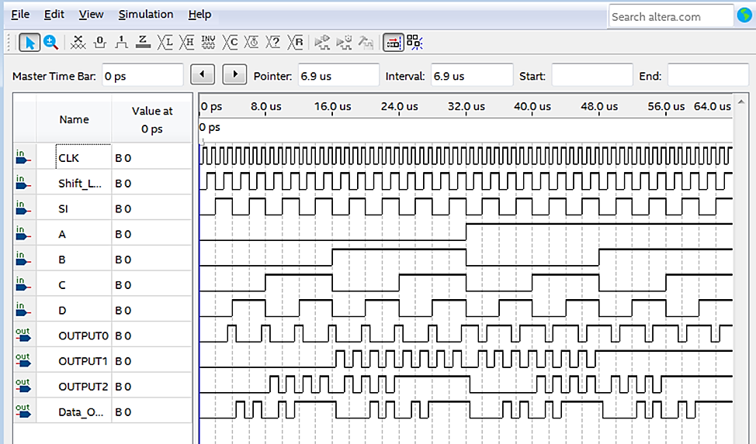

Рис. 6